**Brenda Sue List Huffines**

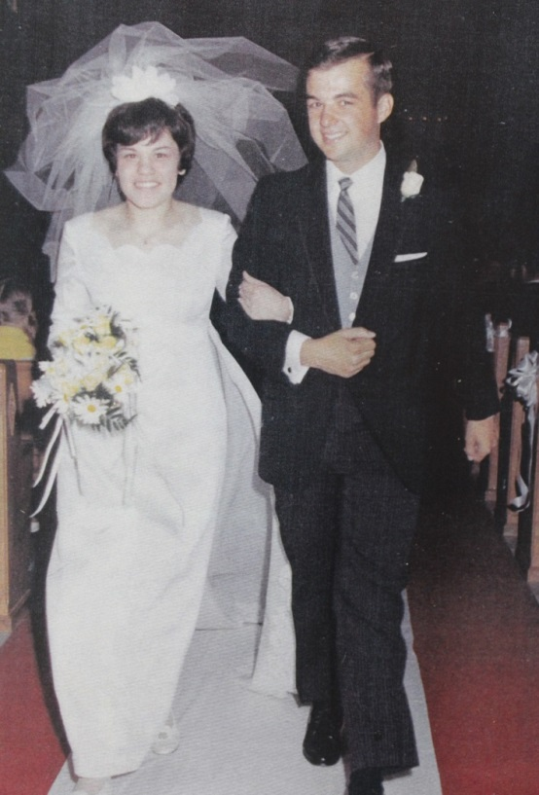

Brenda Sue List and husband, Thomas Goss Huffines - 11 May 1969

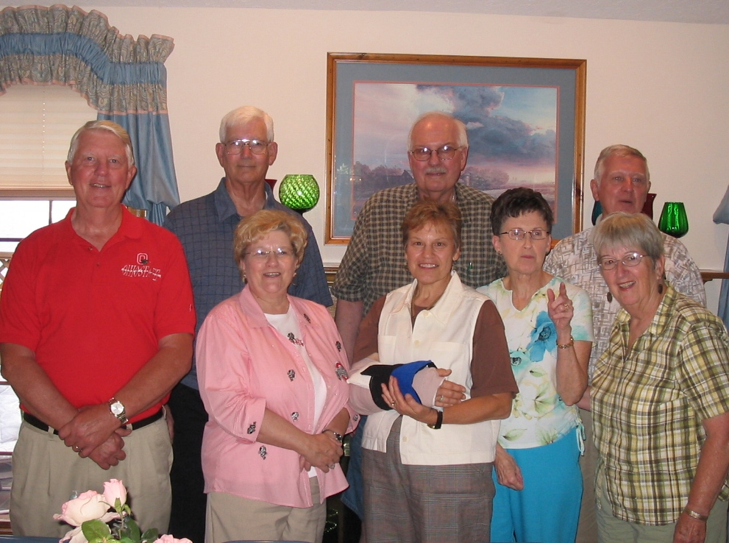

(l-r) David List, Don Raasch, Ronald List, Mark List, Carolyn Huffer List,

Brenda Huffines, Janette Chapman List, Colleen Ernst, (Brenda’s partner) – 2008